



JDBC

Sadhu Sreenivas C -DAC Hyderabad

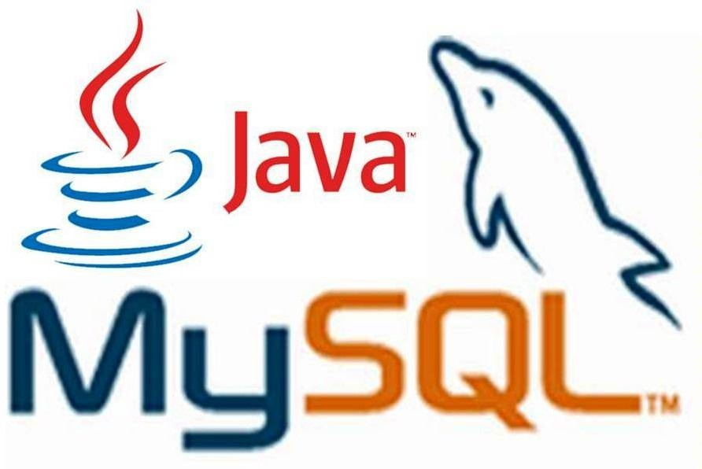



What is JDBC?

- JDBC is a Java-based data access technology (Java Standard Edition platform) from Oracle Corporation.
- This technology is an API for the Java programming language that defines how a client may access a database.
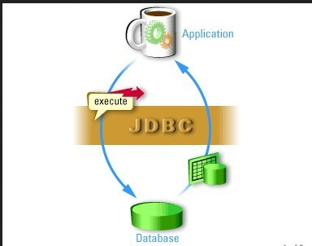
- It provides methods for querying and updating data in a database.

JDBC History

- Before JDBC, ODBC API was used to connect and execute query to the database.
- But ODBC API uses ODBC driver that is written in C language which is platform dependent and unsecured.
- Sun Micro System has defined its own API (JDBC API) that uses JDBC driver written in Java language.

- Sun Microsystems released JDBC as part of JDK 1.1 on February 19, 1997.
- The JDBC classes are contained in the Java package java.sql

- Some classes and interfaces are available javax.sql

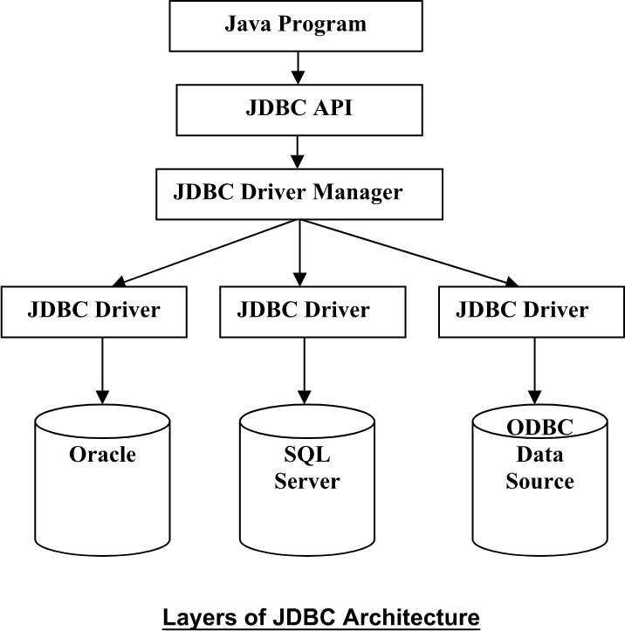

What is API




The Java API is the set of classes included with the Java Development
C -DAC Hyd
- Environment. These classes are written using the Java language and run on the JVM. The Java API includes everything from collection classes to GUI classes.

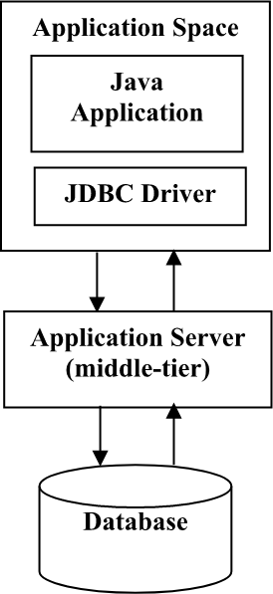
- JDBC is also an API.

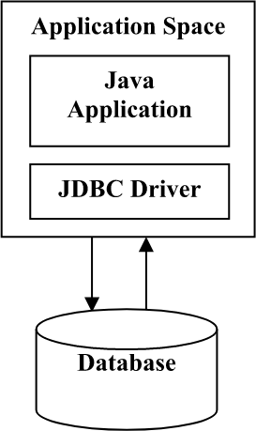

JDBC Drivers

- JDBC Driver is a software component that enables java application to interact with the database.There are 4 types of JDBC drivers:
  - Type 1: JDBC-ODBC bridge driver
  - Type 2: Native-API driver (partially java driver)
  - Type 3: Network Protocol driver (fully java driver)
  - Type 4: Thin driver (fully java driver)

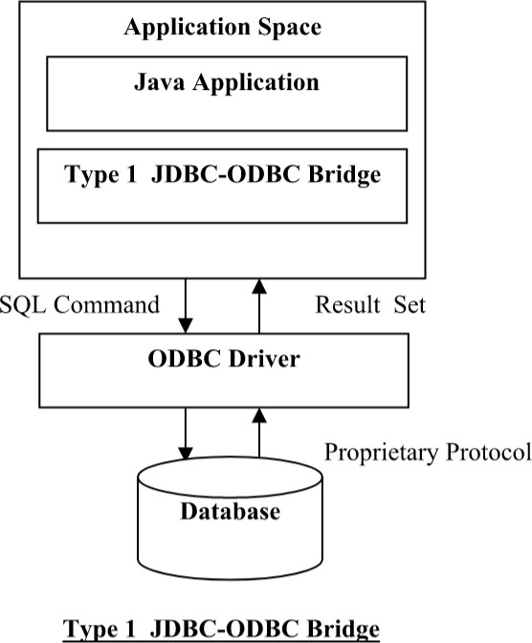
- The JDBC-ODBC bridge driver uses ODBC driver to connect to the database. This is now discouraged because of thin driver.

The Native API driver uses the client-side libraries of the database.
- ​
It is not written entirely in Java.
- ​

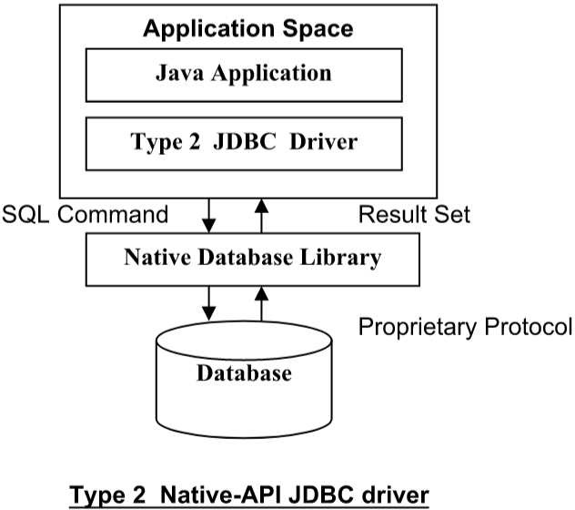

C -DAC Hyd
The Network Protocol driver uses middle ware (application server).
- ​
It is fully written in Java.
- ​
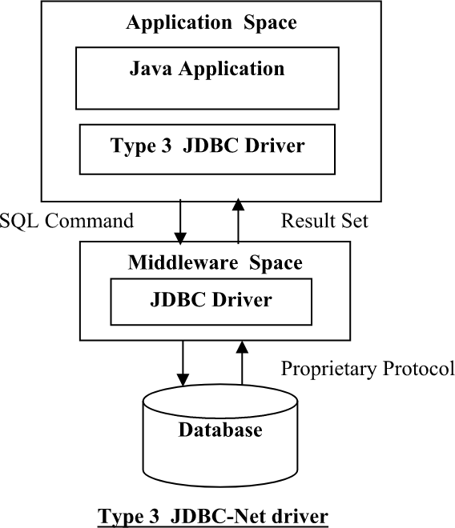


Type 4: Thin Driver
C -DAC Hyd

- The thin driver converts JDBC calls directly into the vendor-specific database protocol.
  - It is known as thin driver. It is fully written in Java

Better performance than all other drivers.
●
  - No software is required at client side or server side.
  - Disadvantage: Drivers depends on the Database.
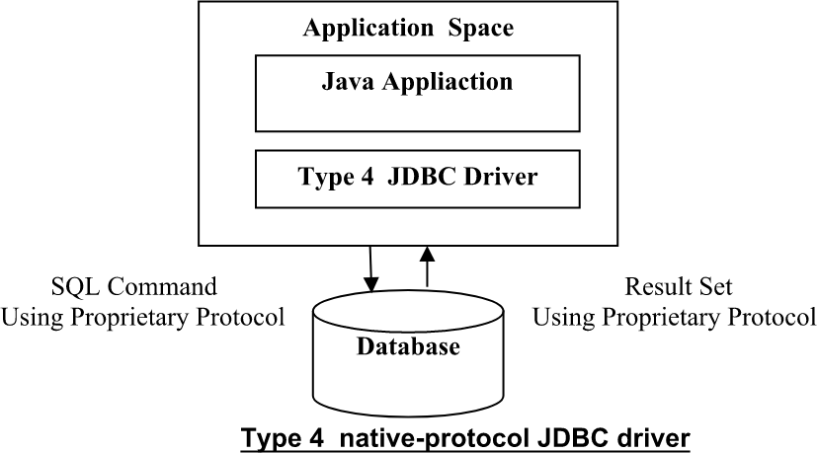

Steps to Connect to the Database in Java

There are 5 steps to connect any java application with the database in java using JDBC. They are as follows:
  - Register the driver class
  - Creating connection
  - Creating statement
  - Executing queries
  - Closing connection

  - The forName() method of Class class is used to register the driver class.
  - Class.forName("com.mysql.jdbc.Driver");

  - The getConnection() method of DriverManager class is used to establish connection with the database.
  - Connection
con=DriverManager.getConnection( "jdbc:mysql://localhost:3306","r oot","password");

  - The createStatement() method of Connection interface is used to create statement. The object of statement is responsible to execute
queries with the database.
  - Statement stmt=con.createStatement();

  - The executeQuery() method of Statement interface is used to execute queries to the database. This method returns the object of ResultSet that can be used to get all the records of a table.
  - ResultSet rs=stmt.executeQuery("select * from emp");

while(rs.next()){
System.out.println(rs.getInt(1)+" "+rs.getString(2));
}

  - By closing connection object statement and ResultSet will be closed automatically. The close() method of Connection interface is used to close the connection.
  - con.close();

Connecting to the MySQL Database

Connect to MySQL Database

  - Driver class: com.mysql.jdbc.Driver.
Connection URL: jdbc:mysql://localhost:3306/db_name
  - ​
Username: The default username for the mysql database is root.
  - ​

  - Password: Given by the user at the time of installing the mysql database
  - Example:
Connection
con=DriverManager.getConnection( “jdbc:mysql:// localhost:3306/cdac","root","admin");

Loading the .jar

  - Download the MySQL connector.jar from mysql.com

Paste the mysqlconnector.jar in the lib folder of source directory. Set the classpath

  - The DriverManager class acts as an interface between user and drivers.
  - It keeps track of the drivers that are available and handles establishing a connection between a database and the appropriate driver.
  - Connection con = null;
con=DriverManager.getConnection( "jdbc:mysql://localhost:3306","r oot","password");
  - DriverManager.registerDriver().

  - A Connection is the session between Java application and database.
  - The Connection interface is a factory of Statement and PreparedStatement.
  - Object of Connection can be used to get the object of Statement and PreparedStatement.

Methods of Connection interface:
  - public Statement createStatement(): creates a statement object that can be used to execute SQL queries.
  - public void commit(): saves the changes made since the previous commit/rollback permanent.
  - public void close(): closes the connection and Releases a JDBC resources immediately.

  - The Statement interface provides methods to execute queries with the database.
  - The statement interface is a factory of ResultSet.
  - It provides factory method to get the object of ResultSet.

Methods of Statement interface:
  - public ResultSet executeQuery(String sql): is used to execute SELECT query. It returns the object of ResultSet.
  - public int executeUpdate(String sql): is used to execute specified query, it may be create, drop, insert, update, delete etc.
  - public boolean execute(String sql): is used to execute queries that may return multiple results.

Example:
  - Statement stmt=con.createStatement();
int result=stmt.executeUpdate("delete from table where id=xy"); System.out.println(result+" records affected");
con.close();

  - The object of ResultSet maintains a cursor pointing to a particular row of data.
  - Initially, cursor points to before the first row.

Methods of ResultSet interface:
  - public boolean next(): is used to move the cursor to the one row next from the current position.
  - public boolean previous():is used to move the cursor to the one row previous from the current position.
  - public boolean first(): is used to move the cursor to the first row in result set object.
  - public boolean last():is used to move the cursor to the last row in result set object.

Methods of ResultSet interface:
  - public int getInt(int columnIndex): is used to return the data of specified column index of the current row as int.
  - public int getInt(String columnName): columnName): is used to return the data of specified column name of the current row as int.
  - public String getString(int columnIndex): is used to return the data of specified column index of the current row as String.
  - public String getString(String columnName): is used to return the data of specified column name of the current row as String.

Example:
ResultSet rs=stmt.executeQuery("select * from table");
  - ​
//getting the record of 3rd row rs.absolute(3);
System.out.println(rs.getString(1)+" "+rs.getString(2)+"
"+rs.getString(3)); con.close();

The PreparedStatement interface is a sub interface of Statement.
  - ​
It is used to execute parameterized query.
  - ​

  - Example of parameterized query:
– String sql="insert into emp values(?,?,?)";

Methods of PreparedStatement:
  - public void setInt(int paramIndex, int value): sets the integer value to the given parameter index.
  - public void setString(int paramIndex, String value): sets the String value to the given parameter index.
  - public void setFloat(int paramIndex, float value): sets the float value to the given parameter index.

Methods of PreparedStatement:
  - public void setDouble(int paramIndex, double value): sets the double value to the given parameter index.
  - public int executeUpdate(): executes the query. It is used for create, drop, insert, update, delete etc.
  - public ResultSet executeQuery(): executes the select query. It returns an instance of ResultSet.

Example:
  - PreparedStatement stmt=con.prepareStatement("insert into Emp values(?,?)");
stmt.setInt(1,101);//1 specifies the first parameter in the query stmt.setString(2,”ABC");
int i=stmt.executeUpdate(); System.out.println(i+" records inserted");

Questions

Write a program to implement CRUD in a table. Write a program to implement PreparedStatement?



Thank You

C -DAC Hyd

